Bus Topology

What Is Bus Topology?
# Source: AI Source: Provided by: [Data Path: Persons Table -> ID Column: 1, Name_En Column: Motasem Essam] -> From: [ChatGPT] on [12/18/2025]
A bus topology is a network design where all devices are connected to a single central cable, called the bus or backbone. It was one of the earliest and simplest types of LAN topologies.

🧠 Simple Definition:
# Source: AI Source: Provided by: [Data Path: Persons Table -> ID Column: 1, Name_En Column: Motasem Essam] -> From: [ChatGPT] on [12/18/2025]
In a bus topology, all devices are connected to one communication line (the bus), and data travels along this line until it reaches its destination.

📷 Visual Representation:
# Source: AI Source: Provided by: [Data Path: Persons Table -> ID Column: 1, Name_En Column: Motasem Essam] -> From: [ChatGPT] on [12/18/2025]
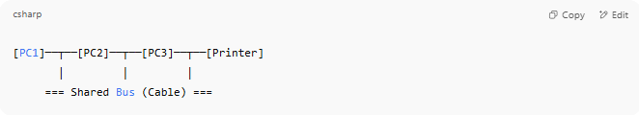
[PC1]──┬──[PC2]──┬──[PC3]──┬──[Printer]
│ │ │
=== Shared Bus (Cable) ===

📦 How It Works
# Source: AI Source: Provided by: [Data Path: Persons Table -> ID Column: 1, Name_En Column: Motasem Essam] -> From: [ChatGPT] on [12/18/2025]
- Only one device can transmit at a time.
- Devices listen on the bus for data addressed to them.
- Uses terminators at both ends to prevent signal bounce.

🔁 Data Flow Example
# Source: AI Source: Provided by: [Data Path: Persons Table -> ID Column: 1, Name_En Column: Motasem Essam] -> From: [ChatGPT] on [12/18/2025]
- PC1 wants to send data to PC3.
- PC1 places data on the bus.
- All devices see the data, but only PC3 accepts it (matches address).
- Others ignore it.

✅ Advantages
# Source: AI Source: Provided by: [Data Path: Persons Table -> ID Column: 1, Name_En Column: Motasem Essam] -> From: [ChatGPT] on [12/18/2025]
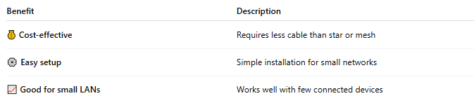
Benefit | Description
💰 Cost-effective | Requires less cable than star or mesh
⚙️ Easy setup | Simple installation for small networks
📈 Good for small LANs | Works well with few connected devices

❌ Disadvantages
# Source: AI Source: Provided by: [Data Path: Persons Table -> ID Column: 1, Name_En Column: Motasem Essam] -> From: [ChatGPT] on [12/18/2025]
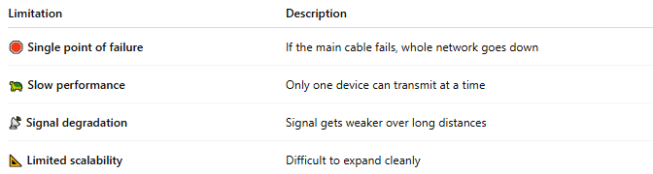
Limitation | Description
🛑 Single point of failure | If the main cable fails, whole network goes down
🐢 Slow performance | Only one device can transmit at a time
📡 Signal degradation | Signal gets weaker over long distances
📐 Limited scalability | Difficult to expand cleanly

🛠️ Components in a Bus Topology
# Source: AI Source: Provided by: [Data Path: Persons Table -> ID Column: 1, Name_En Column: Motasem Essam] -> From: [ChatGPT] on [12/18/2025]
- Main cable (coaxial typically)
- T-connectors
- Terminators at both ends
- Network devices (PCs, printers, etc.)

📍 Use Cases
# Source: AI Source: Provided by: [Data Path: Persons Table -> ID Column: 1, Name_En Column: Motasem Essam] -> From: [ChatGPT] on [12/18/2025]
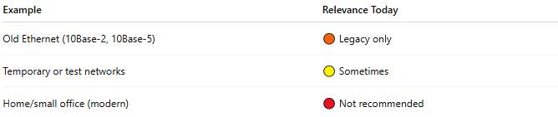
Example | Relevance Today
Old Ethernet (10Base-2, 10Base-5) | 🟠 Legacy only
Temporary or test networks | 🟡 Sometimes
Home/small office (modern) | 🔴 Not recommended

✅ Summary
# Source: AI Source: Provided by: [Data Path: Persons Table -> ID Column: 1, Name_En Column: Motasem Essam] -> From: [ChatGPT] on [12/18/2025]
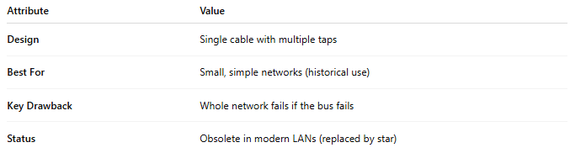
Attribute | Value
Design | Single cable with multiple taps
Best For | Small, simple networks (historical use)
Key Drawback | Whole network fails if the bus fails
Status | Obsolete in modern LANs (replaced by star)

